Luis Ruiz

Assignment 0

CPE 301 – 1001

1. **PART 0**

The assignment took me an overall 30 minutes to complete. I got a little bit carried away going through some features Atmel studio offered.

1. **PART A**

My design consists of three distinct integers greater than 30 but less than 60 being added up to produce a sum and determine if at any given time there was an overflow. I consider the integer values to be signed, therefore the sum must be between $-2^{7}…{(2}^{7}-1)$ otherwise an overflow would occur because our MSB would be one (0b1xxx_xxxx), hence it’s a negative in 2s compliment. Once an overflow is detected it goes to a label Overflow, configures PortB bit positon 4 to be an output while the rest to be inputs and after PortB bit position 4 will be assigned a high to output. The code then continues; however, this time I intentionally let add integers that sum produce a value less than 127. Thus when I sum up the signed integer values the overflow flag should never be set and should branch to the noOverflw label. Once at the noOverflw label it configure PortB bit position 2 to be an output and output a low.

**PART B**

;

; DA0_1.asm

;

; Created: 1/24/2017 3:22:31 PM

; Author : Luis

;

; Replace with your application code

main:

LDI r16,55 ;r16 = 55

LDI r17,45 ;r17 = 45

ADD r16,r17 ;r16 += r17 (r16 = 45 + 55)

brvs Overflw ;if Overflow flag is set goto Overflw

LDI r17, 50 ;r17 = 50

ADD r16,r17 ;r16 += r17 (r16 = 100 + 50)

;flag should set here and goto Overflw

brvs Overflw ;if Overflow flag is set goto Overflw

;I intentionally add numbers that add

; and create a sum less than 127

back:

LDI r16,31 ;r16 = 31

LDI r17,32 ;r17 = 32

ADD r16,r17 ;r16 += r17 (r16 = 31 + 32)

LDI r17, 33 ;r17 = 33

ADD r16,r17 ;r16 += r17 (r16 = 63 + 33)

;the overlow flag shoul be zero and go to noOverflw

brvc noOverflw ;if Overflow flag is not set goto NoOverflw

rjmp end

Overflw:

LDI r17, 0x10 ;r16 = 0b0000_0100

OUT DDRB, r17 ;configure Port B bits input: 7:3 & 1:0, output: 2

OUT PORTB, r17 ;turn PortB on

rjmp back

noOverflw:

LDI r16, 0x10 ;r16 = 0b0000_0100

OUT DDRB, r16 ;configure Port B bits input: 7:3 & 1:0, output: 2

LDI r16, 0x00 ;r16 = 0b0000_0000

OUT PORTB, r16

end:nop

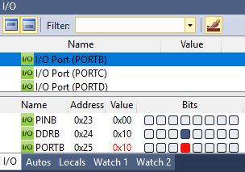**PART C**

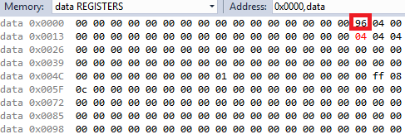**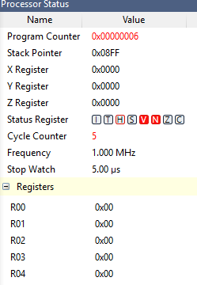 Overflow Occurred**

The running sum was being held by reg16 (0x10) which indicates a value of 150, it is pass the signed value of 127 thus an overflow

The running sum was being held by reg16 (0x10) which indicates a value of 150, it is pass the signed value of 127 thus an overflow

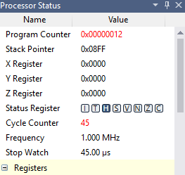**No Overflow Occurred**

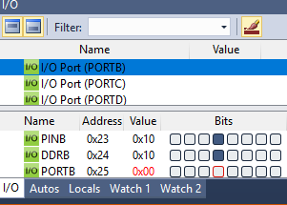

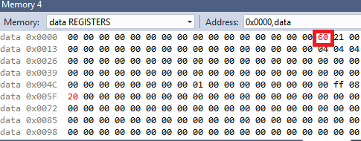

The overflow flag doesn’t get set since r16 value is 112 and is less than 127 therefore PORTB bit position 3 outputs a low

**PART D**

URL Video of Design Assignment 0: <https://youtu.be/yx41uX9qbLM>

**PART E**

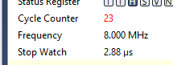 $$Execution Time=\frac{Cycle Counter}{Frequency }=\frac{23}{8.00MHz}≈2.88 µs$$